Written Portion

Assignment 3, PHYS 512

Simon Harms, 260841508

1. The rk4_stepd function was about 10 times more accurate than rk4_step going by the residual graphs.
2. I used the Radau solver because the U238 amount changed much slower than the others so we were safe to use the faster solver. Half of the U238 becomes Pb206 at around ~3.4 billion years and the U238 curve is roughly inverse exponential, both of which make sense analytically given that the half life of U238 is ~4.5 billion years and the amount is expected to drop off exponentially.
3. [](https://www.codecogs.com/eqnedit.php?latex=z%20-%20z_0%20%3D%20a((x-x_0)%5E2%20%2B%20(y-y_0)%5E2)#0)

[](https://www.codecogs.com/eqnedit.php?latex=z%20-%20z_0%20%3D%20a(x%5E2%20-2x%20x_0%20%2B%20x_0%5E2%20%2B%20y%5E2%20-2y%20y_0%20%2B%20y_0%5E2)#0)

[](https://www.codecogs.com/eqnedit.php?latex=z%20%3D%20a(x%5E2%20%2B%20y%5E2)%20-2ax_0%20(x)%20-%202ay_0(y)%20%2B%20(ax_0%5E2%20%2B%20ay_0%5E2%20%2B%20z_0)#0)

[](https://www.codecogs.com/eqnedit.php?latex=z%20%3D%20a(x%5E2%20%2B%20y%5E2)%20%2B%20bx%20%2B%20cy%20%2B%20d#0)

With [](https://www.codecogs.com/eqnedit.php?latex=a%20%3D%20a#0), [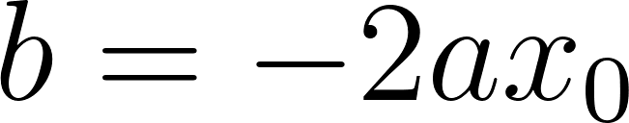](https://www.codecogs.com/eqnedit.php?latex=b%20%3D%20-2ax_0#0), [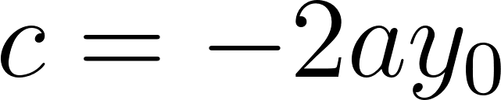](https://www.codecogs.com/eqnedit.php?latex=c%20%3D%20-2ay_0#0), and [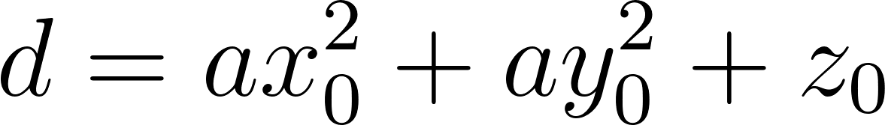](https://www.codecogs.com/eqnedit.php?latex=d%20%3D%20ax_0%5E2%20%2B%20ay_0%5E2%20%2B%20z_0#0). We can get x0, y0, and z0 back by going [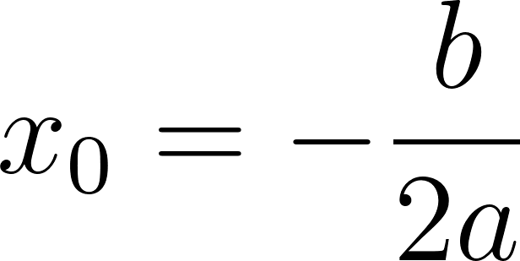](https://www.codecogs.com/eqnedit.php?latex=x_0%20%3D%20-%5Cfrac%7Bb%7D%7B2a%7D#0), [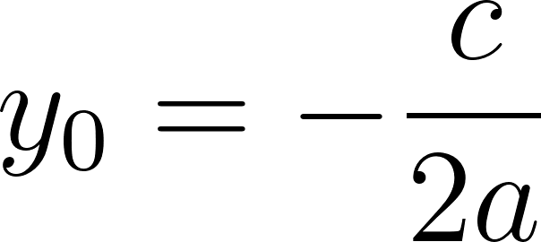](https://www.codecogs.com/eqnedit.php?latex=y_0%20%3D%20-%5Cfrac%7Bc%7D%7B2a%7D#0), and then [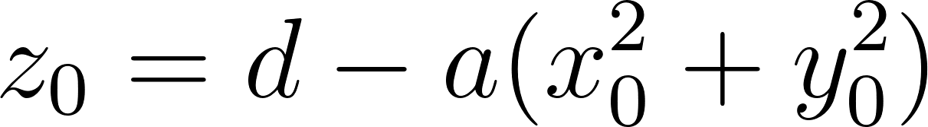](https://www.codecogs.com/eqnedit.php?latex=z_0%20%3D%20d%20-%20a(x_0%5E2%20%2B%20y_0%5E2)#0).